**Installing nginx web-server**

**Step 17:** Now, we will be installing NGINX web server on the VM.

sudo apt-get -y install nginx

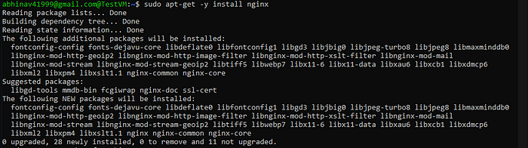

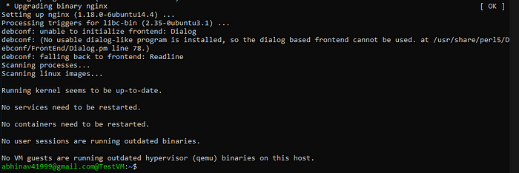

**Step 18:** Now, we will check the status of the NGINX web server.

sudo systemctl status nginx

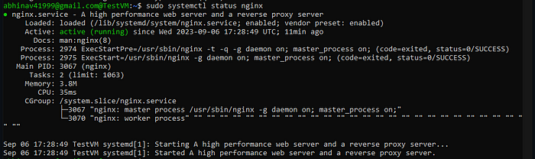

**Step 19:** Now, we will check the status of the NGINX web server on the browser.

http://<PUBLIC IP ADDRESS>/

